Lokmangal College of Agriculture Business Management, Wadala.

11.7: Extension activities/ Shetkari Melava

Sr. No. | Activity | Date
1 | Workshop on Strawberry Crop Cultivation Bio- Fertilizer Management | 12/02/2021
2 | Workshop on Soil testing | 26/04/2022
3 | Shetkari Melava on Karif crop management | 07/06/2022
4 | Shivar Pheri on the occasion of World Soil Day | 05/12/2022 to 09/12/2022
5 | Participated in MPKV Climax,2022  Rahuri, Dist. Ahmednagar | 19/12/2022 to 21/12/2022
6 | Participated in Siddheshwar Krushi Pradarshan, 2022 , Solapur | 25/12/2022 to 29/12/2022
7 | Workshop on Drone Awareness | 23/01/2023
8 | Shivar Pheri on the occasion of World Soil Day | 06/12/2023 to 13/12/2022

- Workshop : Strawberry crop cultivation and Bio- fertilizers Management
Guest for workshop : Dr. Sachin C. Phuge
Dr. Jeetendra Bajare
Date of event: 12/02/2021
Venue: Hall No. 12 (Training Hall)
Lokmangal College Campus, Wadala
No. of Participants: 32

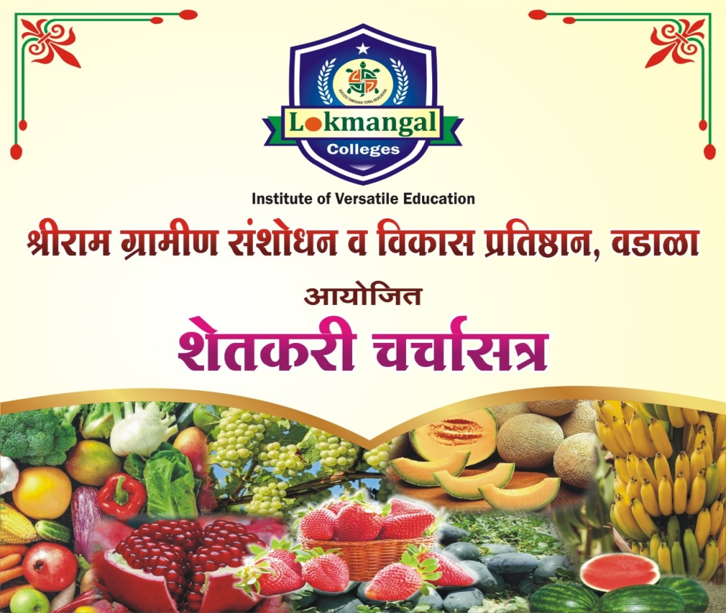
Invitation Card
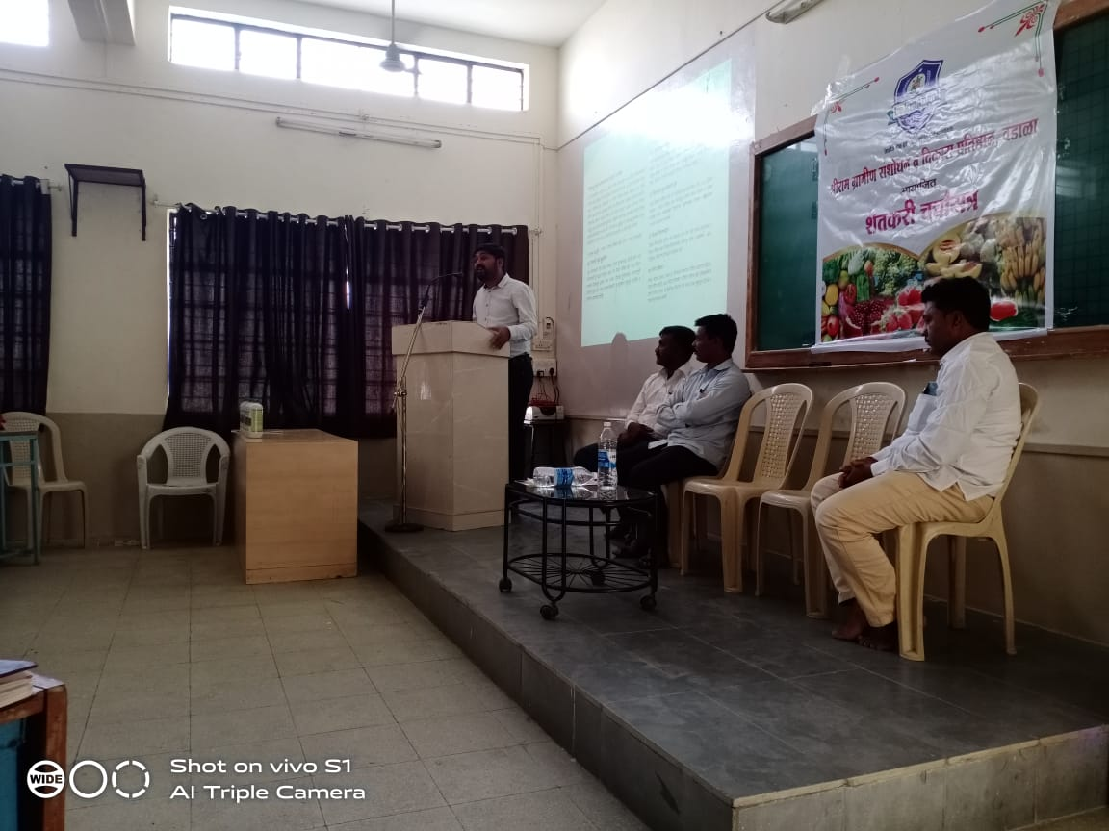
While Delivering topic

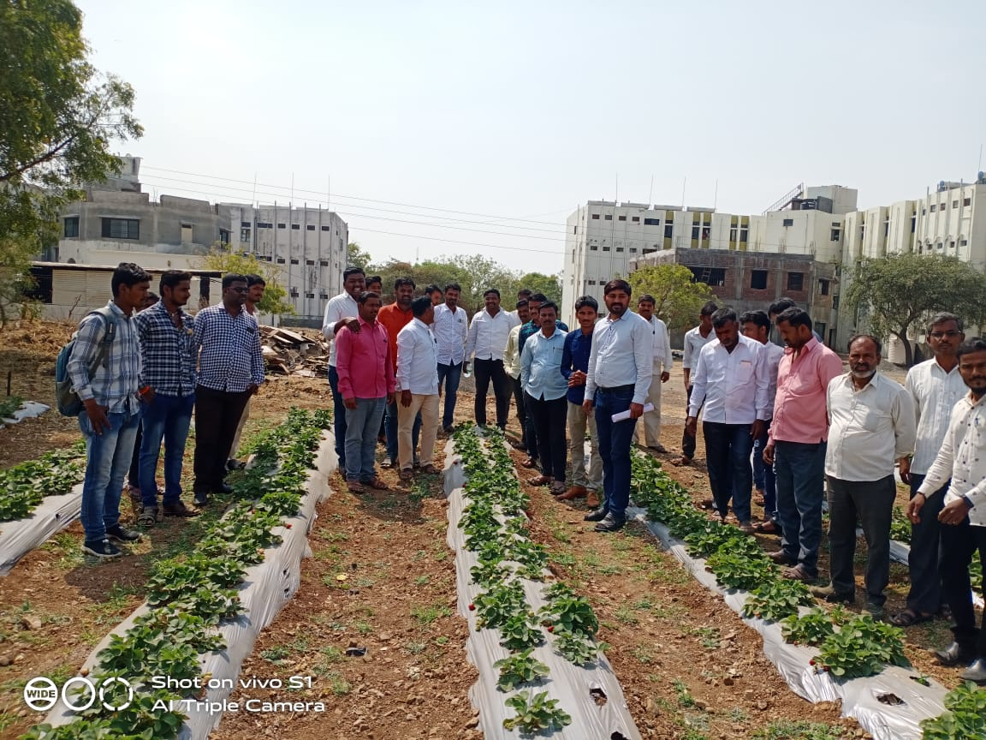
Farmers visit at strawberry plot
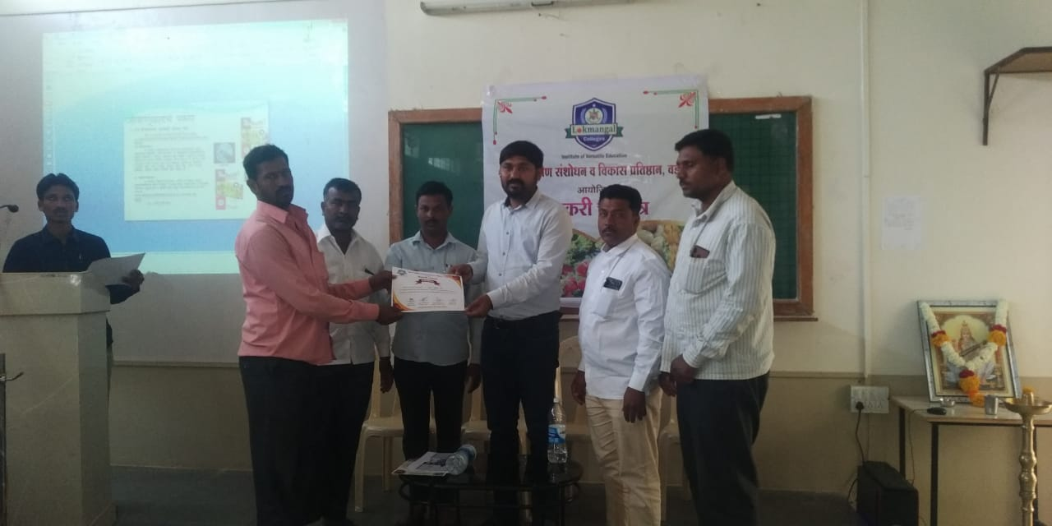
While certificate distribution to Participant farmers
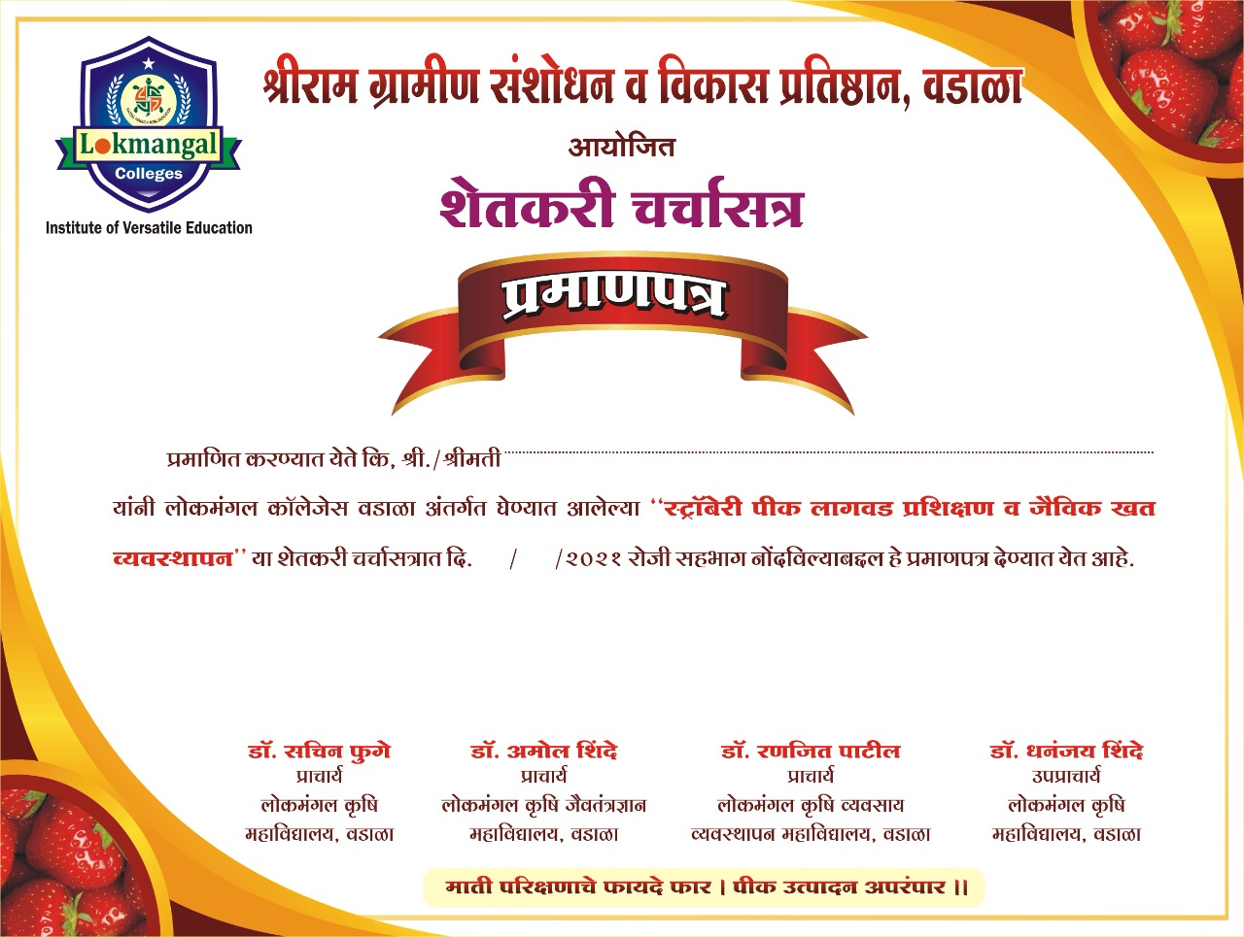

- Workshop : Workshop on Soil testing
Guest for workshop : Dr. Sachin C. Phuge
Prof. K.S Dhadave
Date of event: 26/04/2022
Venue: At. Post – Ranmasale,
Tq. North Solapur, Dist. Solapur
No. of Participants: 102
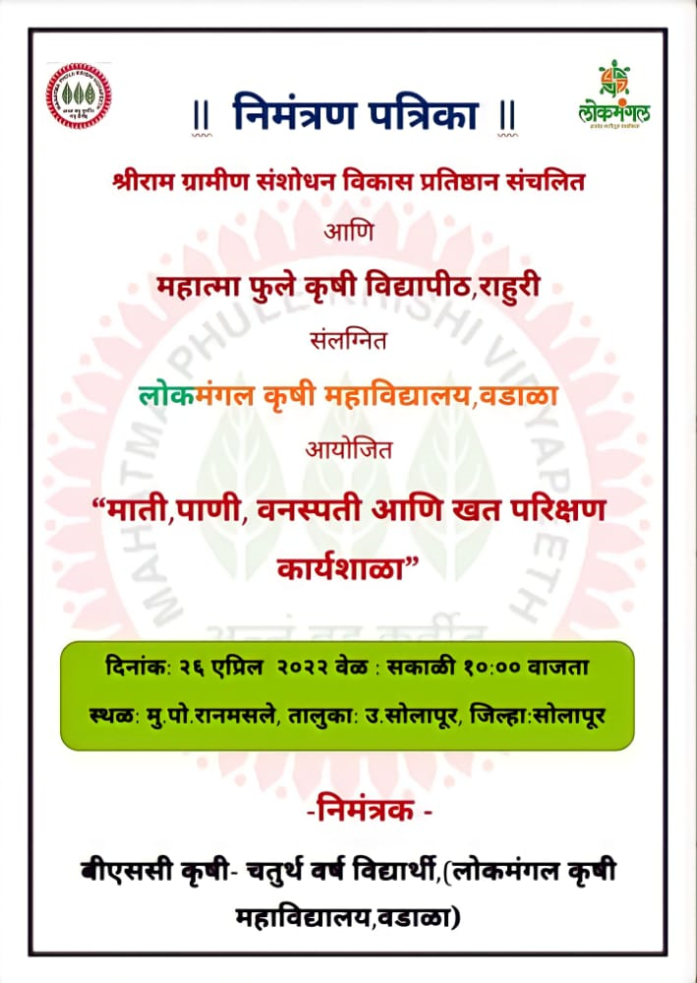
Invitation Card
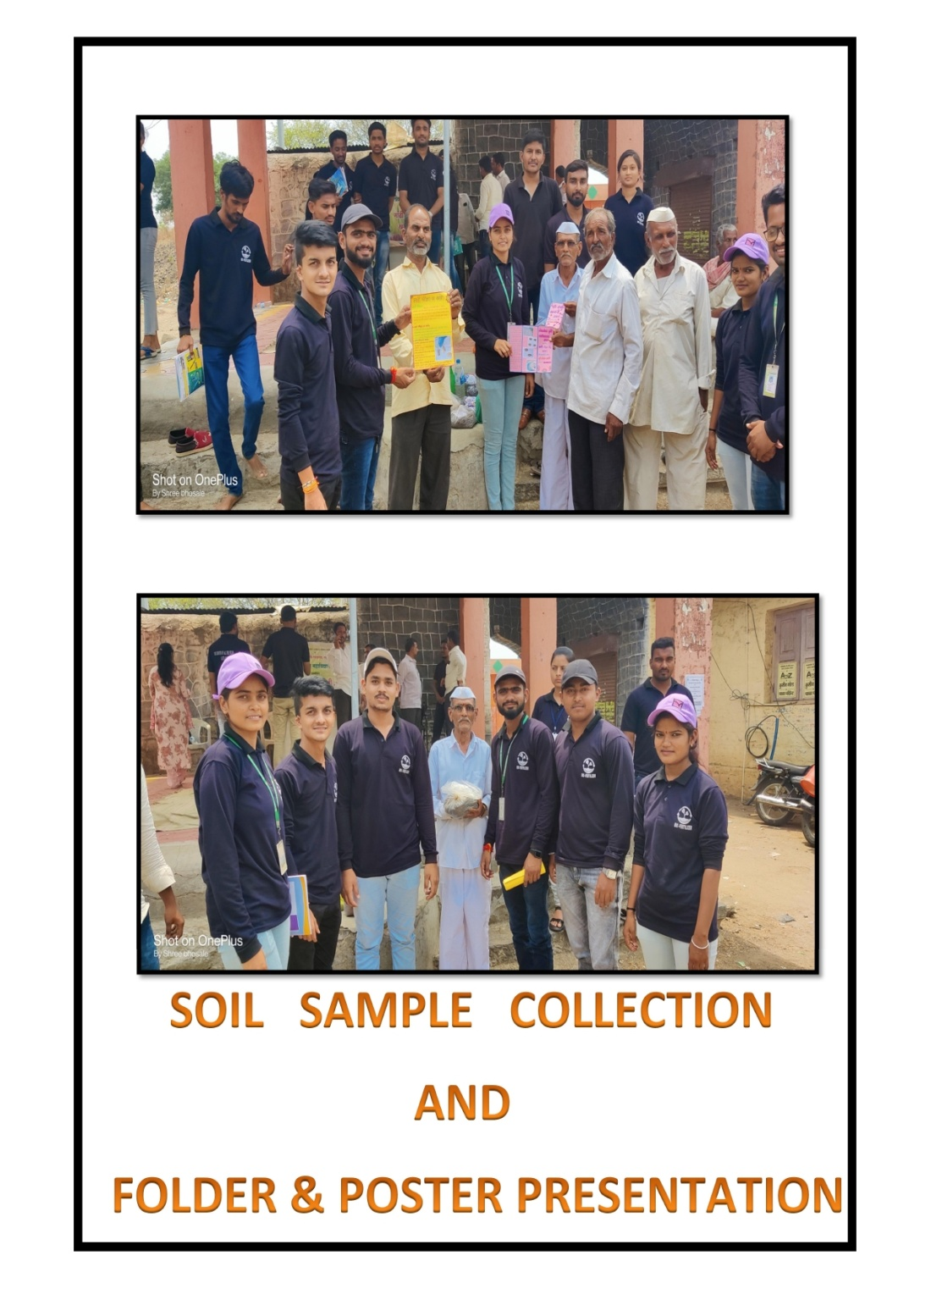

- Participated : Climax, 2022
Staff : Prof. Sagar Patil
Prof. P. N. Shelake
Date of event: 19/12/2022 to 21/12/2022
Venue: Mahatma Phule Krushi Vidhyapeeth, Rahuri
Dist. Ahmedenagar
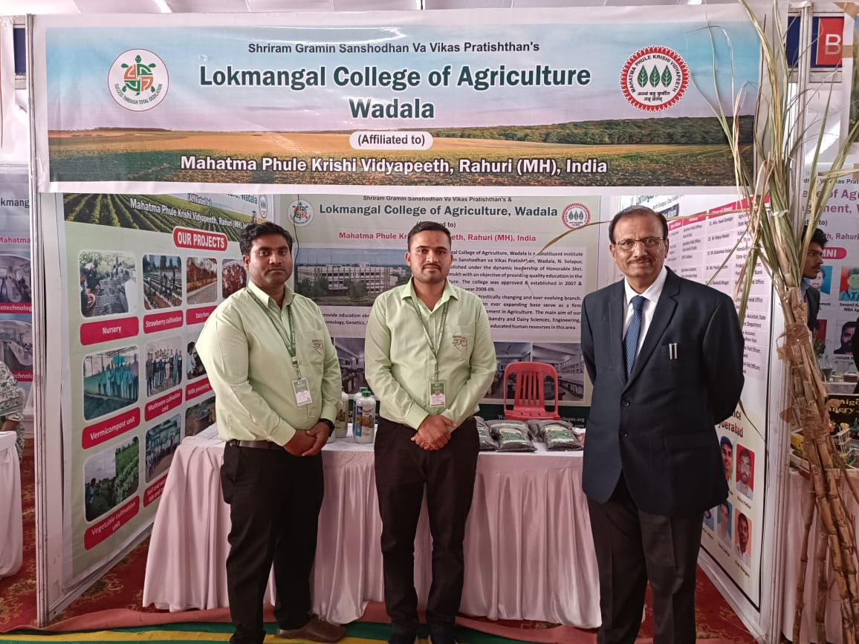
Hon. Dr. P. G. Patil, Hon. Vice- Chansellor, MPKV, Rahuri Visited to college stall
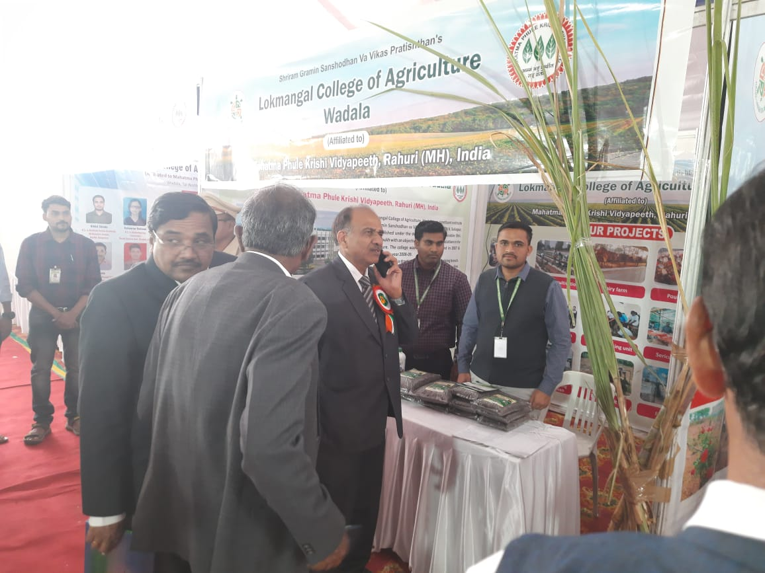
Hon. Ex. Dean, Hon. Registrar, Hon. Director of Research from MPKV, Rahuri visited to college stall
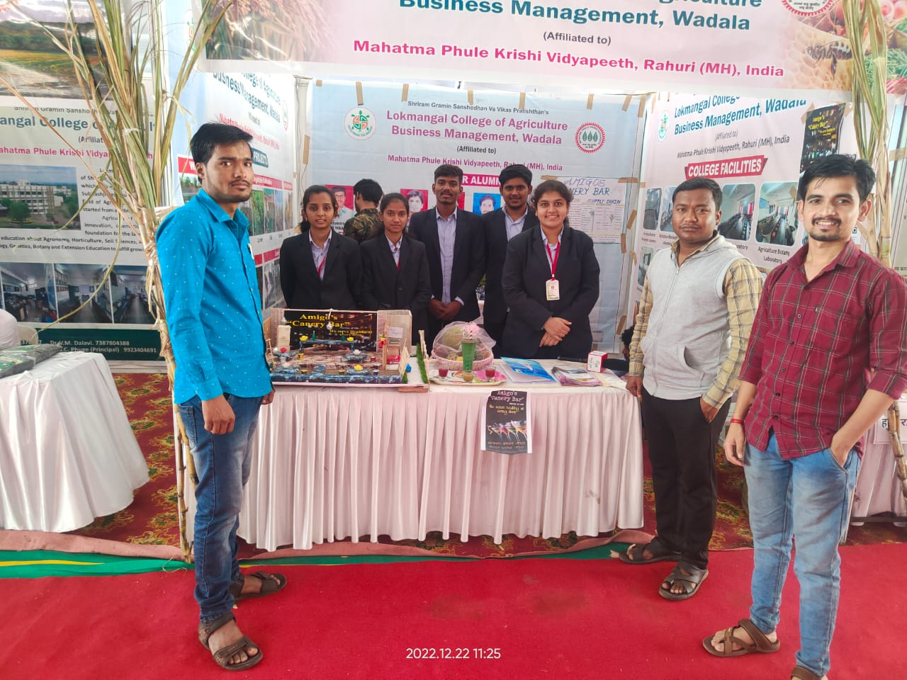
College Stall, Staff and Students
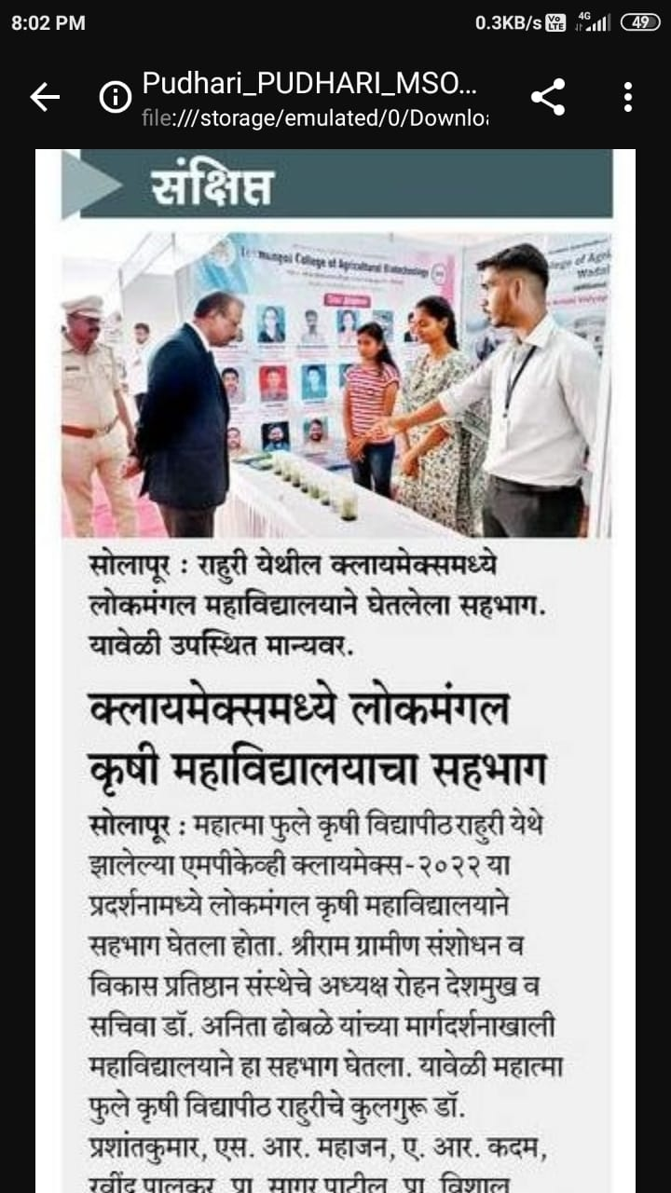
News: Dainik Pudhari Date-24/12/2022

- Participated : Siddheshwar Krushi Pradarshan, 2022
Staff : Prof. Ganesh Jadhav
Prof. P. N. Shelake
Date of event: 25/12/2022 to 29/12/2022
Venue: Home Ground, Solapur
Dist. Solapur
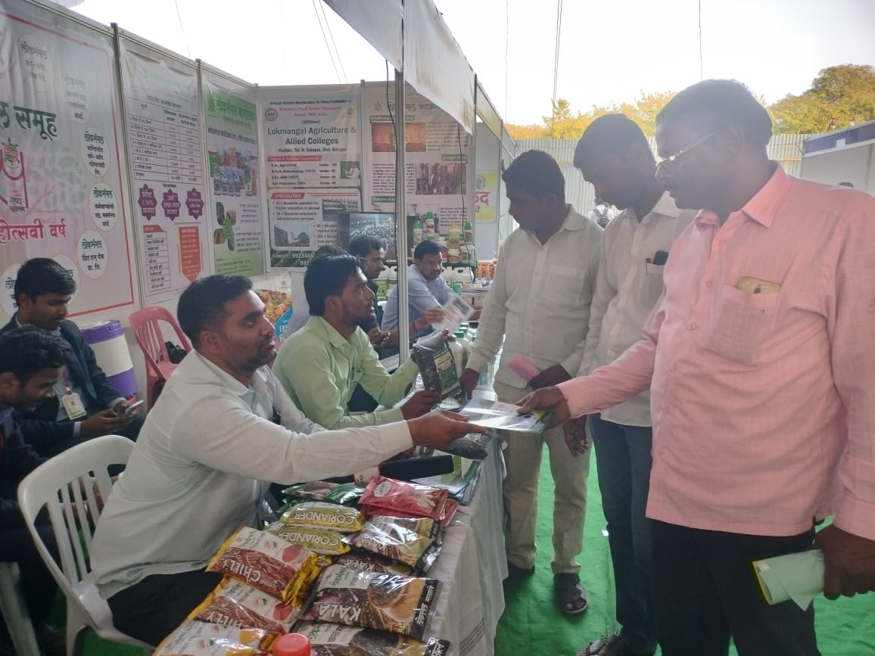
Farmers visited stall
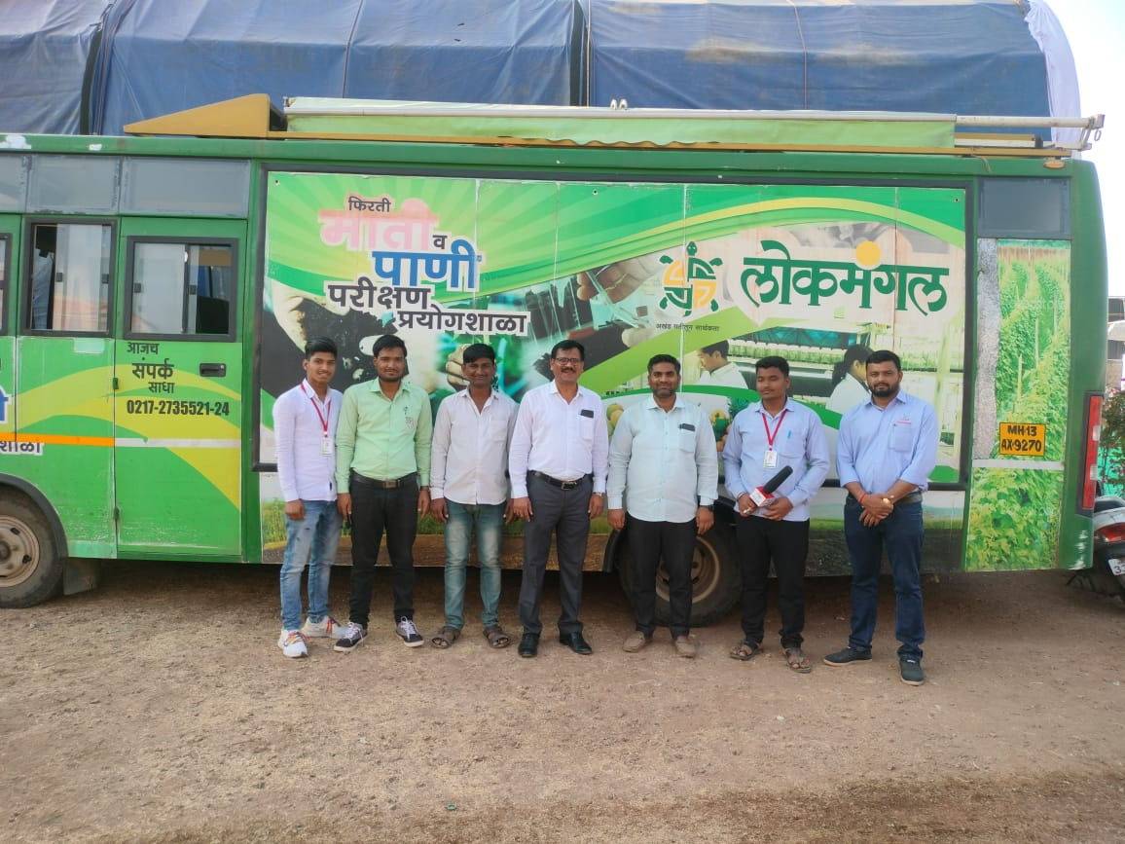
Taluka Agriculture Officer, State Agri. Deparment, Maharashtra visited to College Soil & Water testing van

