11.6 ) Intercollegiate Sports competition organization
Lokmangal College of Agriculture Business Management, Wadala

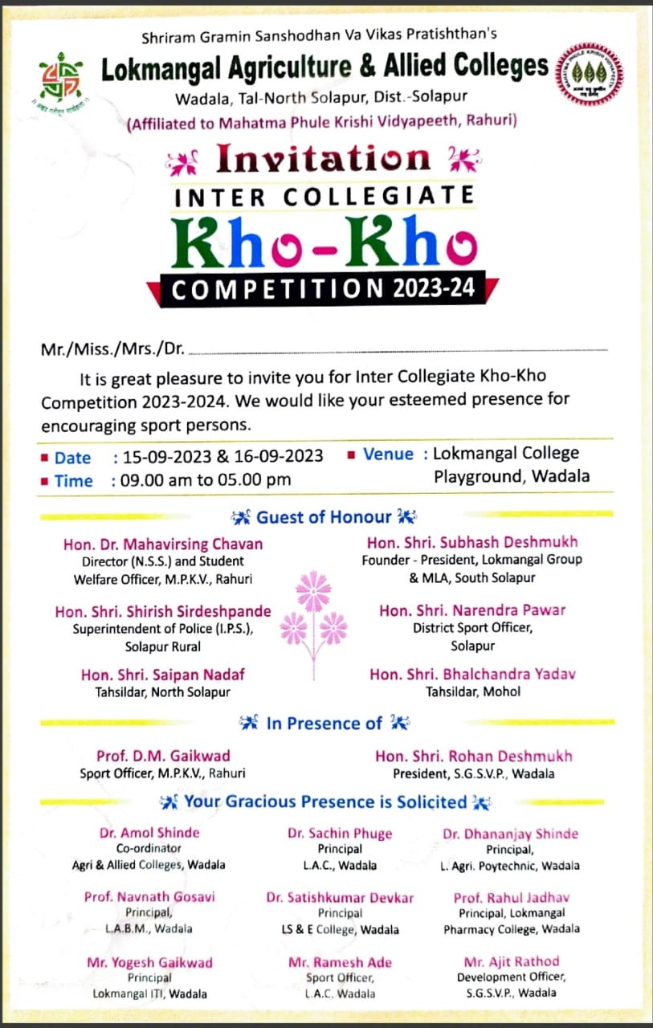

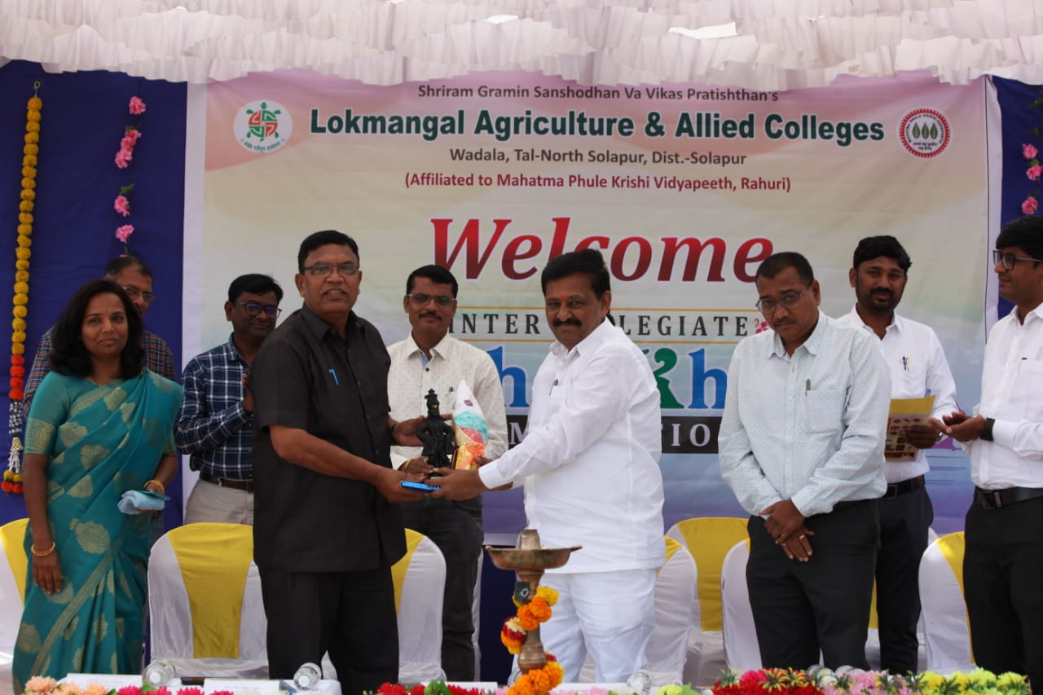
Plate 1.- Hon. Subhash (Bapu ) Deshnukh felicitated to Hon. Prof. D. M. Gaikwad, Sport Officer, MPKV., Rahuri at the time of Opening ceremony

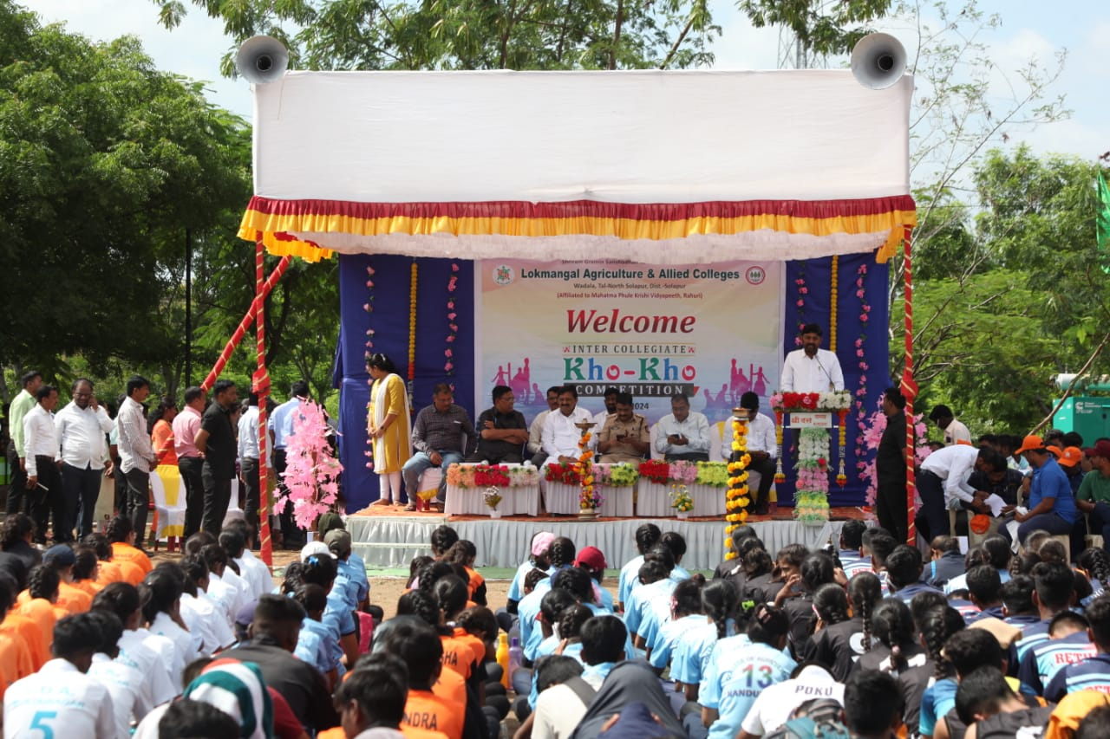
Plate 2.- Intercollegiate Sports competition Opening ceremony Programme and Particpated Teams form university affiliated Agri. And Agri Allied Colleges

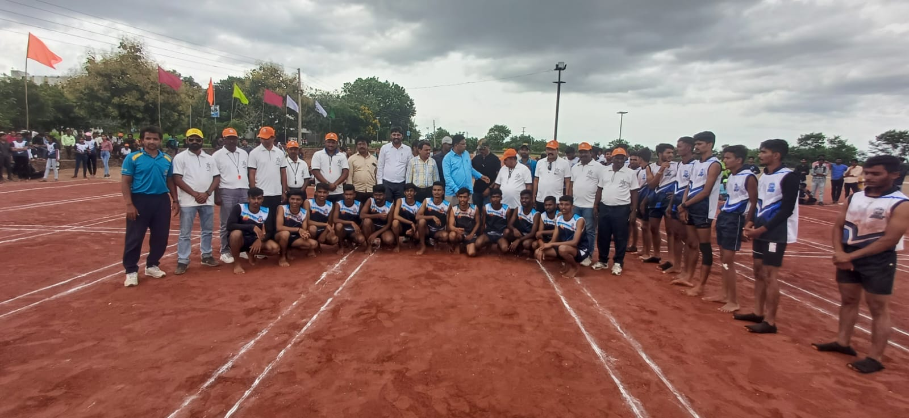
Plate 3.- Respected dignitaries, coach, referee etc. offering best wishes to both teams

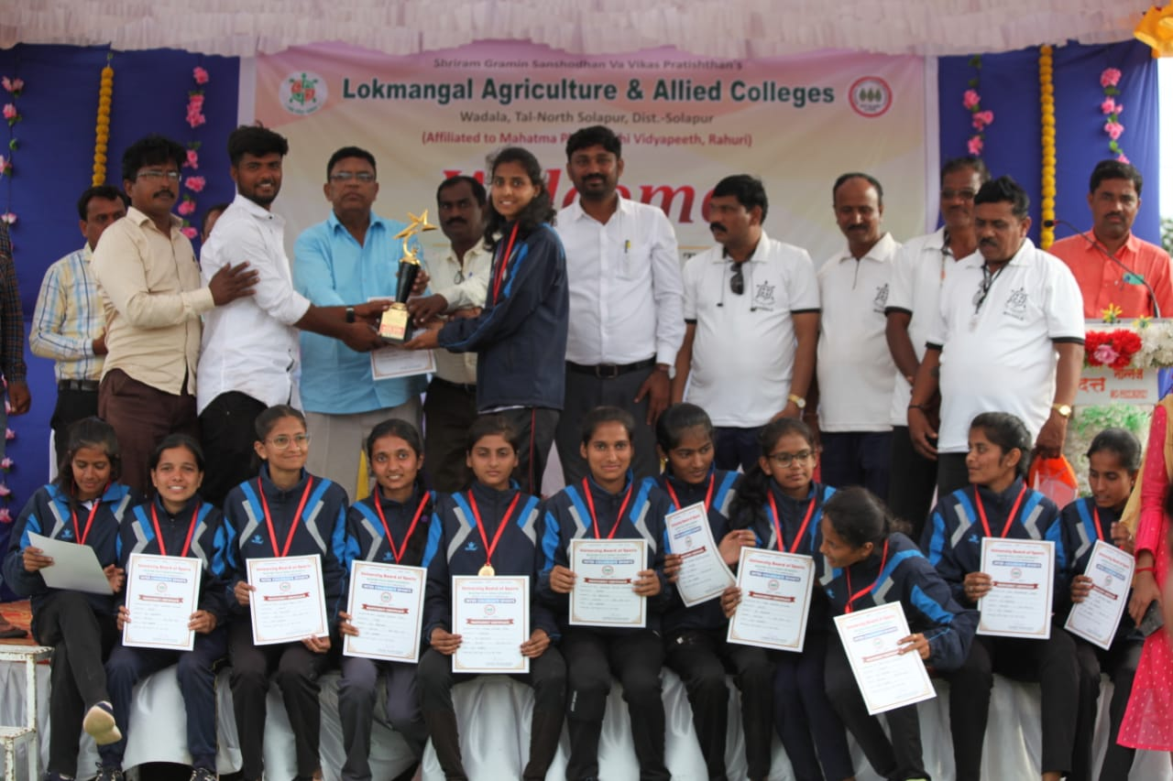
Plate 4.- Prize distribution ceremony Intercollegiate Sports competition

NEWS
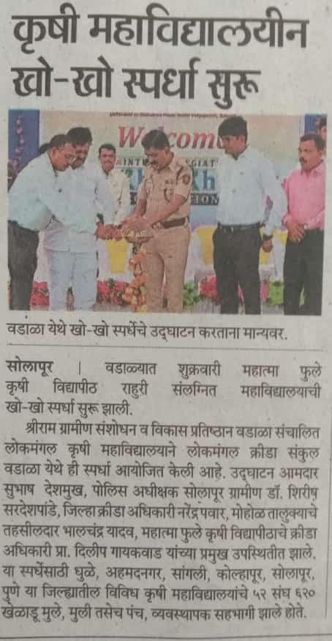 | 